Notebook 2:

NodeJS HTTP Server

**Creating HTTP NodeJS server:**

**First, you have to run the command npm install -g http-server while inside of the command prompt, when you are located in the correct directory.**

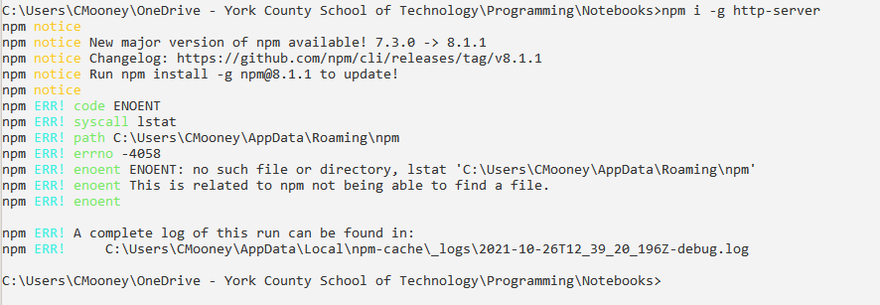

**After this you need to run the command npm init to install the rest of the required server files, otherwise it will constantly spit back an error and refuse to run**

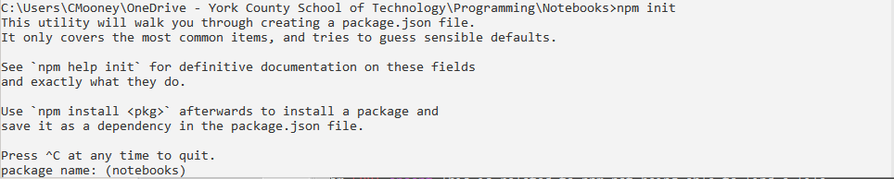

You also need to fill out all of the information that follows NPM init with the correct information for your server, or you can just leave it blank:

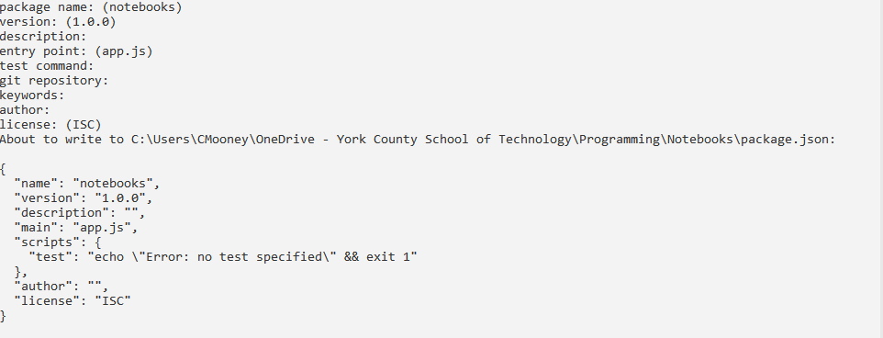

Once all of the installing is done, you have to create a .html file and a .js file so that way your server can run. I am going to name mine index.html and app.js (The server automatically creates the package.json)

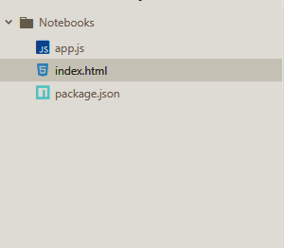

Once all of your files are created and filled out, you can run the command **Node (name).js**, and once you do that, the server will run and you will have to go to the ip address **localhost:(port)** and your server will render for you.